Slow Cooker Hawaiian Chicken

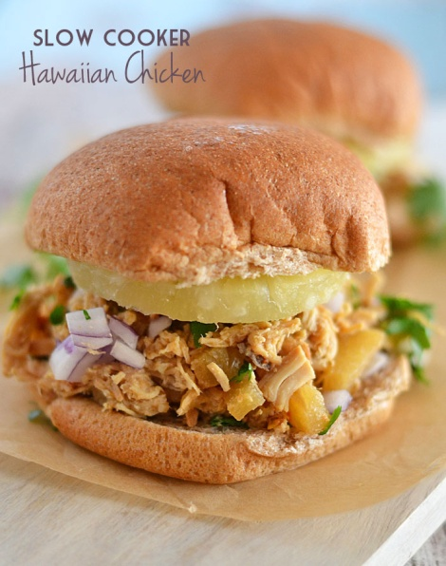

1 pound boneless chicken breasts
1 (20-ounce) can crushed pineapple in juice
juice of one lime
1 tablespoon honey
¼ cup soy sauce
3 or 4 garlic cloves, minced
½ teaspoon red pepper flakes (adjust to your heat preference)
8 whole wheat buns
for serving, optional: pineapple rings, diced red onion, chopped cilantro

Place chicken into crock pot. Cover chicken with remaining ingredients, through the red pepper. Cook on low for 4 to 6 hours. Shred chicken and serve on buns; top with additional pineapple, red onion and/or cilantro. Serves: 8.

Jalapeno Cornbread Whoopie Pies with Goat Cheese and Bacon Filling
For the cakes:
1¼ cups all-purpose flour
1 cup cornmeal
¼ cup packed brown sugar
2 teaspoons baking powder
1 teaspoon salt
1 cup buttermilk
4 tablespoons unsalted butter, at room temperature
1 egg
2 jalapeño peppers, seeded and finely chopped

For the filling:
6 slices bacon, cooked crisp and crumbled
4 ounces goat cheese, at room temperature
4 ounces cream cheese, at room temperature
2 tablespoons milk
1 tablespoon chopped fresh chives

Heat oven to 375º and place rack in center. Line two baking sheets with parchment or a nonstick baking mat. In a medium bowl, whisk together the flour, cornmeal, brown sugar, baking powder and salt. Combine the buttermilk, butter and egg in the bowl of an electric mixer fitted with the paddle attachment. Beat on low speed until just combined, then increase speed to medium and beat for about 3 minutes, or until well combined. Reduce speed to low and add the flour mixture and peppers and beat until just combined.
Using a small cookie scoop or tablespoon, drop the batter onto the prepared baking sheets, spacing about 2 inches apart. Bake for 12 minutes, or until the cakes begin to brown around the edges, rotating the pans halfway through baking. Remove from oven and allow to cool on the pan for 5 minutes, then transfer to a wire rack to cool completely.
While the cakes are baking, make the filling. In the bowl of an electric mixer fitted with the paddle attachment, combine the goat cheese, cream cheese and milk. Beat on low speed until just combined, then increase speed to medium and beat for about 3 minutes, until the mixture is smooth and creamy. Reduce speed to low and add the bacon and chives and beat until just combined.
To assemble the whoopie pies, scoop about a tablespoon (we used the same scoop we used to make the cakes) onto half the cakes. Place the remaining cakes onto the filled cakes and press to sandwich them together. Yield: about 15.

PHILADELPHIA Easter Cheesecakes

1 cup graham cracker crumbs
¾ cup plus 2 Tbsp. sugar, divided
3 Tbsp. butter or margarine, melted
3 pkg. (8 oz. each) PHILADELPHIA Cream Cheese, softened
1 tsp. vanilla
3 eggs
1 cup plus 2 Tbsp. BAKER'S ANGEL FLAKE Coconut, toasted
54 speckled malted milk eggs (about 9 oz.)

HEAT oven to 325°F.
MIX graham crumbs, 2 Tbsp. sugar and butter; press onto bottoms of 18 paper-lined muffin cups.
BEAT cream cheese, vanilla and remaining sugar with mixer until blended. Add eggs, 1 at a time, mixing on low speed after each just until blended. Spoon over crusts.
BAKE 25 to 30 min. or until centers are almost set. Cool completely. Refrigerate 2 hours.
TOP each cheesecake with 1 Tbsp. coconut; shape to resemble bird's nest. Fill with malted milk eggs. Servings: 18.

Rattlesnake Sliders
From Jeff Crump (EzraPoundCake.com)
Makes 12 small burgers
1 1/2 POUNDS GROUND CHICKEN
1 POUND ANDOUILLE SAUSAGE, CASINGS REMOVED, CUT INTO 1-INCH PIECES
1/2 TABLESPOON COURSE GROUND PEPPER
1/2 TABLESPOON KOSHER SALT
1 TEASPOON GARLIC POWDER
1 TEASPOON ONION POWDER
1 TEASPOON GROUND CAYENNE PEPPER
12 SOFT DINNER ROLLS (RECOMMENDED: KING’S HAWAIIAN SWEET ROLLS)
CONDIMENTS: SHREDDED LETTUCE, SLICED TOMATO, CHEESE, SLICED ONION, MAYONNAISE, MUSTARD, KETCHUP, CHILI SAUCE, CHIPOTLE MAYONNAISE (RECIPE BELOW)
- Preheat the grill to medium-high.
- Using a food processor, process the andouille until finely chopped.
- Transfer the andouille to a large bowl. Add chicken, salt, pepper, garlic powder, onion powder and cayenne. Mix gently, being careful not to overwork the mixture.
- Form the mixture into 12 patties, and place them on the grill. Cook until the internal temperature registers 170 degrees F, about 5 minutes per side. During the last minute of grilling, add the cheese to the tops of the burgers, and toast the rolls (cut-side down, about 30 seconds).
- Remove the burgers and buns from the grill. Garnish with your choice of toppings and condiments. Serve immediately.

Chipotle Mayonnaise
1/4 CUP MAYONNAISE
1 CHIPOTLE CHILE IN ADOBO SAUCE, ROUGHLY CHOPPED
DASH OF SALT
Place all of the ingredients into a mini food processor, and blend until smooth. (Or, mix the ingredients well by hand.) Refrigerate until ready to use.

BARBECUED HAM SANDWICHES
1 (12 oz.) bottle chili sauce
1/2 c. ketchup
1/4 c. white vinegar
1/2 c. sugar
4 tsp. (scant) sweet relish
1 tsp. horseradish
1 1/2 to 2 lbs. chipped ham, roughly chopped
Heat first 6 ingredients until bubbly; add ham and heat. Serve on buns.

Mortadella Bites
1 sheet frozen puff pastry (half a 17.3-ounce package), thawed
8 ounces mortadella, cut into 1/2-by-1/2-by-2 1/2-inch batons
1 large egg, beaten
1/2 cup (approximately 2 ounces) grated Gruyere
Dijon mustard, for serving, optional
Preheat the oven to 375 degrees F. Line a baking sheet with parchment paper.
Unfold the sheet of puff pastry and roll into an 11-inch square. Using a pizza wheel or sharp knife, slice the dough into 1/2-inch-thick strips. Wrap each baton of mortadella in one strip of puff pastry, overlapping the dough slightly with each wrap-around to create a spiral appearance in the dough while leaving the mortadella ends exposed.
Place the rolls on the prepared baking sheet, spaced 1 inch apart. Brush each roll with egg and top with a good pinch of Gruyere. Bake until golden brown and puffed, 25 minutes.
Serve warm, with mustard if desired.
BBQ Beef
6 ½ lb. chuck roast
2 stalks celery
4 large onions
2 green peppers
1 20 oz. bottle of ketchup
3 T. vinegar
1 T. hot sauce
1-3 T. chili powder (I used 2)
1 T. salt
1 t. pepper
3 cups water
Bake in oven at 325 for 6 hours turning meat every hour for the first 3-4 hours then every then every ½ hour until done. Add extra water as needed. Shred meat and discard fat. Place shredded meat in a bowl and add the BBQ sauce from the pan. Add some water to the pan to remove the sauce that is stuck to the pan and add that to the meat. Mix well. Add additional water to achieve desired moistness.

